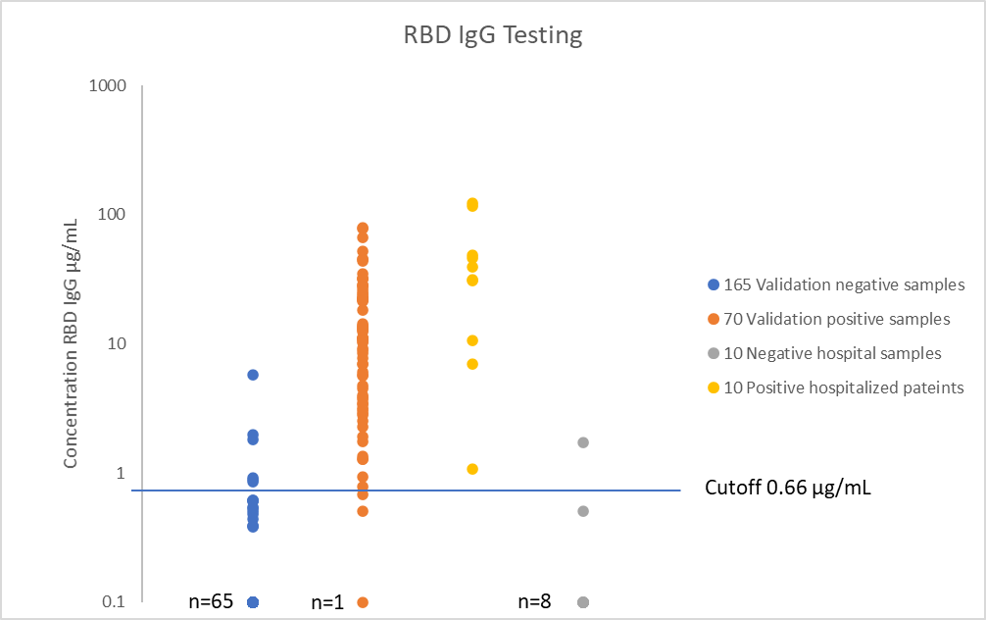

<0.38 µg/mL

|  |  |  |  |  |  |  |
| --- | --- | --- | --- | --- | --- | --- |
| Validation Samples | | Clinical | |  |  |  |
|  | **IgG RBD** | neg | pos |  | n= | 235 |
| lab test | pos | 6 | 68 | 74 | Sensitivity | 97.14% |
| neg | 159 | 2 | 161 | Specificity | 96.36% |
|  |  | 165 | 70 |  |  |  |
|  |  |  |  |  |  |  |

|  |  |  |  |  |  |  |
| --- | --- | --- | --- | --- | --- | --- |
| Hospital samples | | Clinical | |  |  |  |
|  | **IgG RBD** | neg | pos |  | n= | 20 |
| lab test | pos | 2 | 10 | 12 | Sensitivity | 100.00% |
| neg | 8 | 0 | 8 | Specificity | 80.00% |
|  |  | 10 | 10 |  |  |  |
|  |  |  |  |  |  |  |